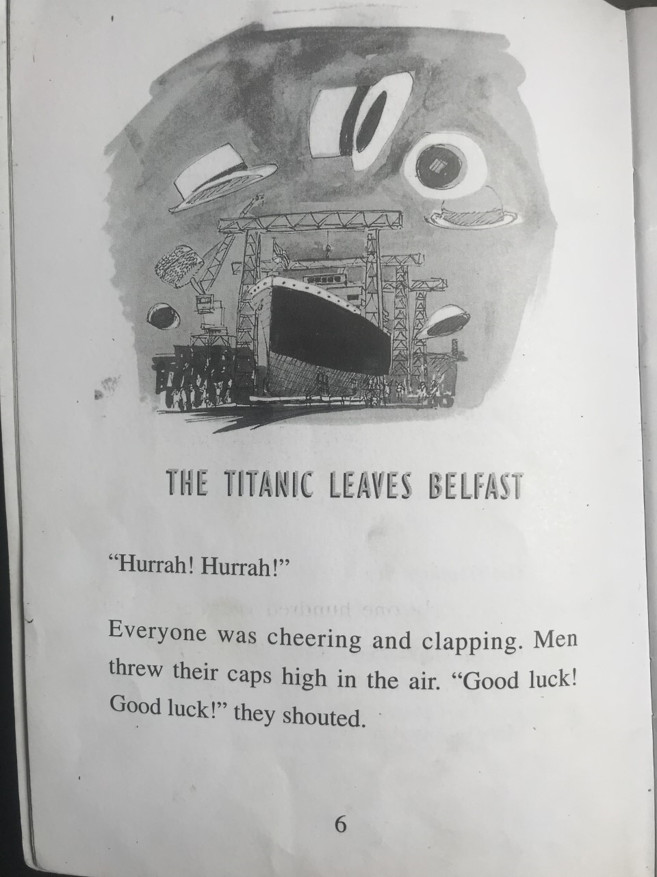
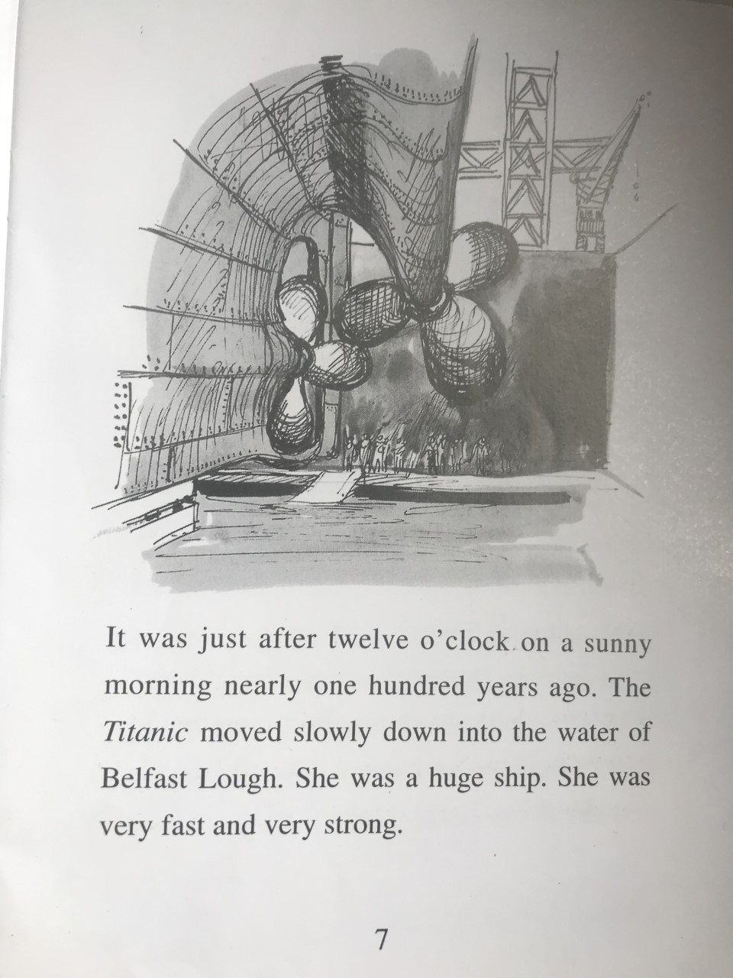
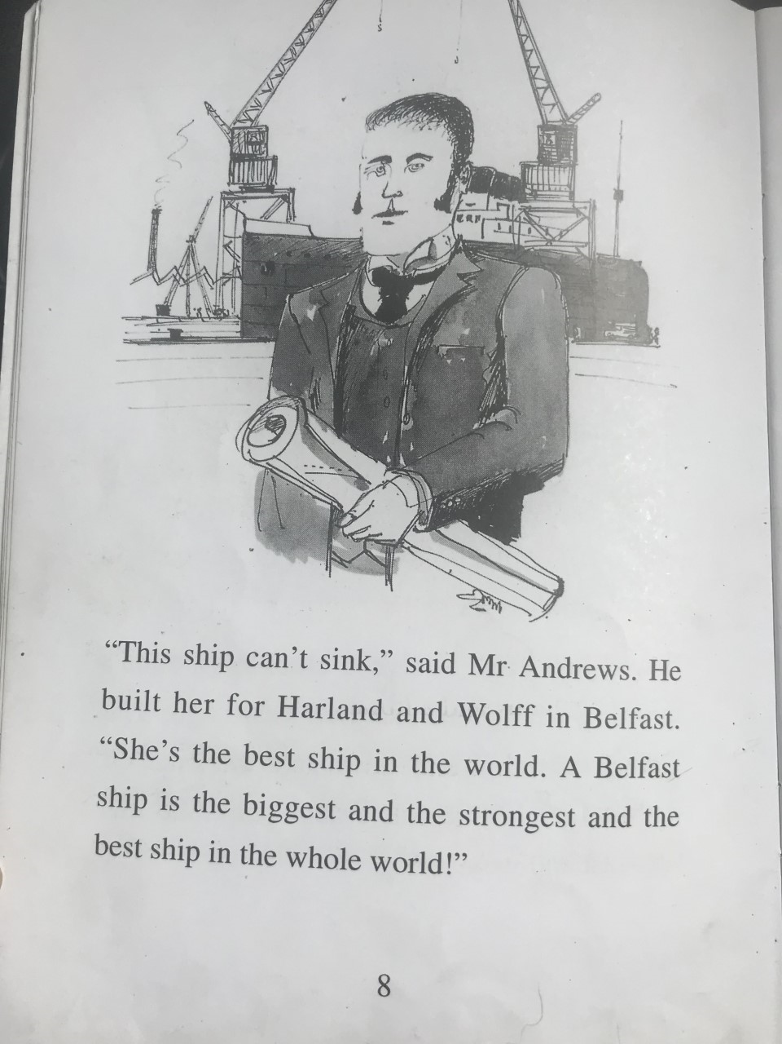
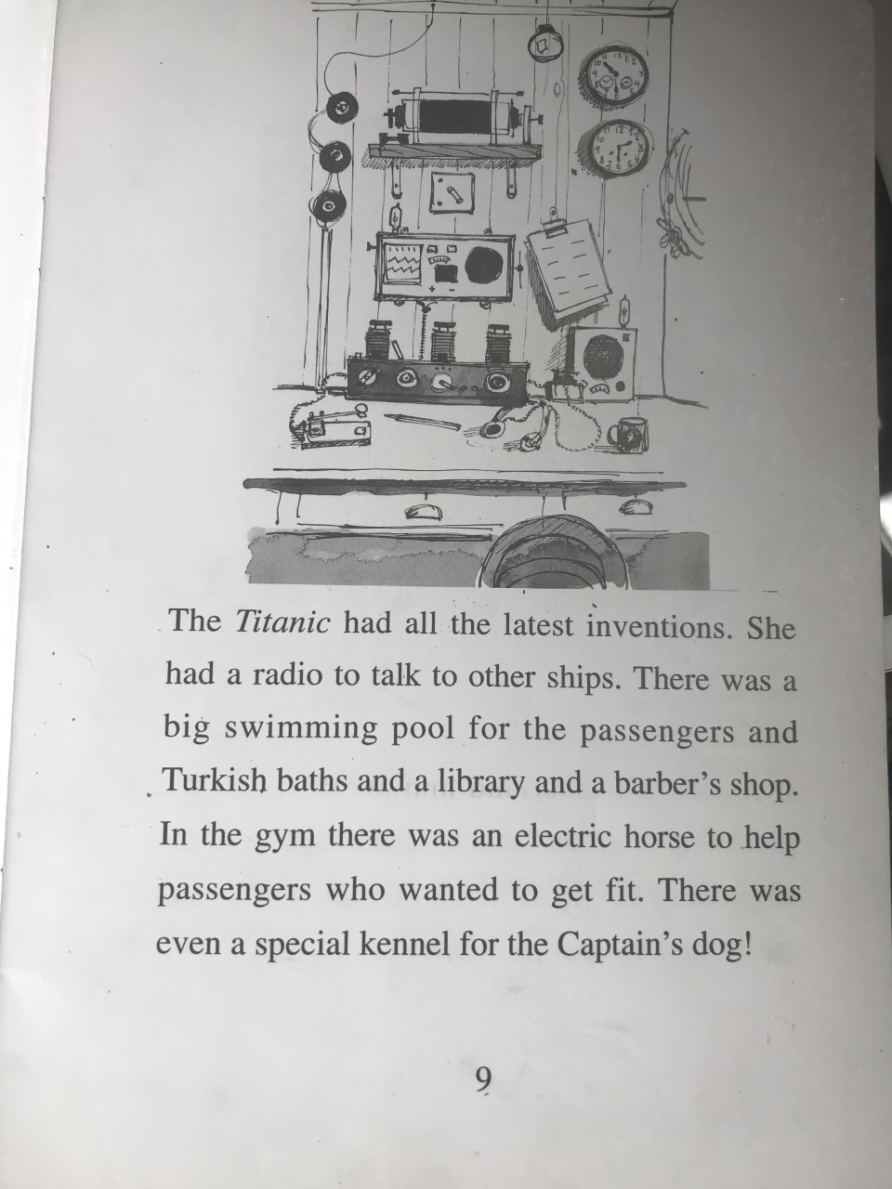
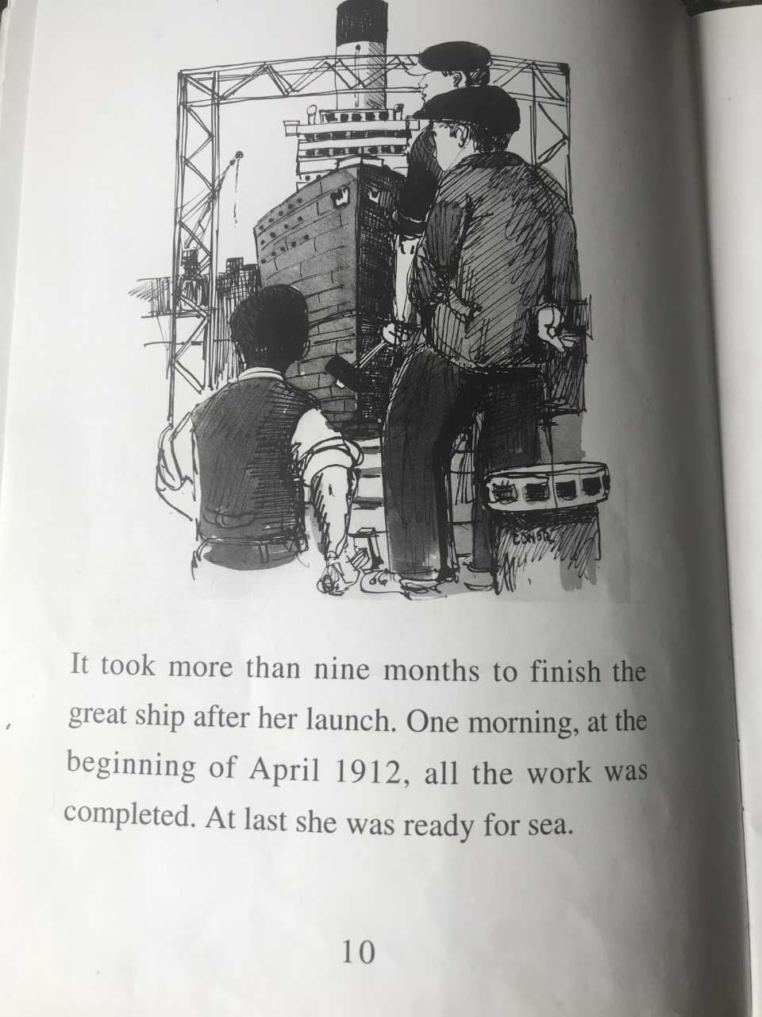

Discussion points:
Why were people cheering and clapping?
Where is Belfast?
“She was very fast and very strong.” Who is she?
When was the Titanic built?
Do you think people would have fun on the Titanic?

Activity:
If you were to build a ship today, what inventions or what facilities would you have on board? Name your ship and draw a picture.

